INTRODUCTION
The monetary policy steps taken by the government ranges from setting the cash reserve ratio, statutory liquidity ratio and changes in other important interest rates which will have direct influence over the investment level and the loans to be taken by the business units. Since 2007, Fed has reduced the federal funds target rate from 5.25% to around 0.25% during December 2008. It is called as the zero lower bound which has been kept intentionally low to meet the requirements of the businesses in the country.

CURRENT MONETARY AND FISCAL POLICIES
Recently, Fed has started raising its interest rates in anticipation of the economic conditions which keeps the target federal funds rate much below the mandate consistent level in the long run. It affects the business units to maintain the required level of investments in the current year. Fed has kept the monetary policy to be simulative in nature which directly affects the investment level through changes in the interest rates. For instance, the investment in the plants and equipment of the business units, spending on the consumer durables and other kinds of residential investments directly affect the aggregate demand in the economy. Exchange rates have been affected by the capital flows due to the divergence between the interest rates affecting the exports and imports of the business units in the country. Due to the recent decrease in the interest rates from 3.56% to 3.24%, there has been promotion of the investments demand in the economy. In the short run, monetary policy can be used to reduce the aggregate spending but in the long run, the main impact of the monetary policy is over the inflation rate. Fed has the strategy of following the zero lower bound in order to promote the unsterilized purchases of treasury and mortgage backed securities for quantitative easing. It enables to promote more transparency and following up of the better economic decisions by the firms.
Fed has undertaken the quantitative easing rounds around three times in the span of five years from 2009 to 2014. It has been announced by the Fed to keep up the interest rates in order to manage its large level of balance sheet by engaging in reverse repo rates of the economy.
It has been projected by the Fed that unemployment rate of the economy will fall below the bare minimum up to the end of 2016 with the inflation rate to be kept below the 2% goal since 2013. In this regard, there will be increase in the sale of the products and services in the economy. However, still there have been debates over how quickly there should be rise in the interest rates so that the risk attached with raising the rates slowly will create financial instability in the system.
Fiscal policy which has been followed by the government makes changes in the taxation and other related rules which directly affects the interest rate levels of the economy by making shifts in the IS curve. Government has increased the indirect taxation rates in the economy which will have negative impact over the sales of the business units because its burden will be transferred over the consumers in the form of higher prices. Thereby, the aggregate demand in the economy will fall down leading to fall in the national income as well. On the other hand, it will act as the simulative for the economy because lower interest rates will increase the investment level in the economy as well. Hence, the demand for home currency would raise leading to its appreciation.
Increase in government spending would have more direct impact to the economy because due to lower consumer confidence people will not increase their consumption even if tax rates would be reduced. Also, the multiplier effect of increase in government spending would have much greater impact over the aggregate demand in the economy.
Due to the instability in the exports of the economy, there has been direct impact over the economic conditions of the foreign counties on our exports. This is because of the positive relationship between the imports and the income level of the economy. Hence, in order to overcome the situation shortages and underproduction, it is necessary for the countries to maintain the buffer stock of few necessary goods. Since, exports and imports are dependent on the exchange rate as well, therefore whenever currencies depreciates, there will be rise in exports and whenever currency appreciates, there will be fall in exports. It would have an impact on the availability of those goods in the importing countries. Therefore, maintenance of buffer stocks is quite important so that market price does not fluctuate drastically.
CHANGES IN THE GDP RATES FROM 1948-1972 and from 1973-2015
As we can see that there has been huge difference between the rate of change in the GDP level of the economy since 1948 to the current period, therefore it can be seen that these changes will have direct impact over the current level of business investments and on the aggregate production level of the economy. There was a drastic fall down in the percentage change in GDP of the economy during 1950s but it started improving around 1972.

On the other hand, from 1972 up to 2015, there have been three times falls down in the percentage change in the GDP level of the economy.

Currently, we have the 2.67% as the natural rate of unemployment in the economy which has been quite low with respect of the disturbances of the economy. On the other hand, current rate of unemployment in the economy is around 4.57% which has been quite high as compared to the other developed nations of the world. Similarly, the relationship between the actual output and potential output of the economy can be assessed through the Okun’s law which establishes the relationship between the two variables on the basis of the recent changes in the policies being followed in the economy. Related to the macroeconomic variables, we have several polices which are being impacted by the macroeconomic risk factors in the economy. The most important risk factor is related to the changes in the government policy with regard to the foreign investment. Higher the foreign investment into the economy, more will be the competition and the risk factor associated with that of the investment level of the business units. (Irwin, 2015)

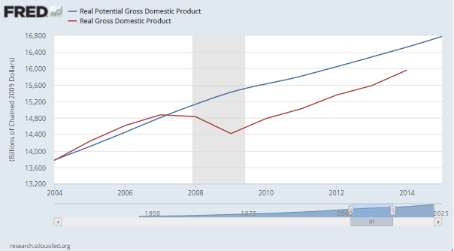 (APPELBAUM, 2011)
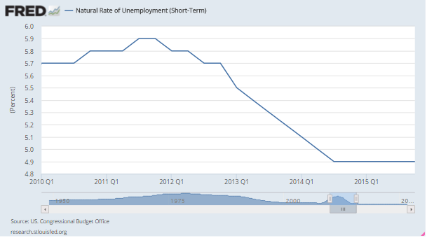
As we can see above, there has been decline in the price level of the products produced in the economy mainly due to the fall in the demand of the products in the key markets of the economy. It happens mostly when there is less actual GDP as compared to the real GDP of the economy leading to the situation of deflation in the economy once the economy have already faced the economic recession.
On the other hand, in case if actual output falls below potential output over time, prices will begin to fall to reflect weak demand. Though rising current account deficit is a cause of concern for any economy but it is not always bad for an economy. However, in recent years it has become a cause of concern for US economy because it has been showing a rising trend since last few years. It has been argued by few policy makers that U.S current account deficit is not sustainable and may create several problems for the economy in the coming future. That is why, due to the negative impact over the U.S economy and other major related economies, the current account deficit is unsustainable and it needs to be corrected at right time using right sets of policies. (Output Gap and Financial Assumptions from the Board of Governors, 2014)
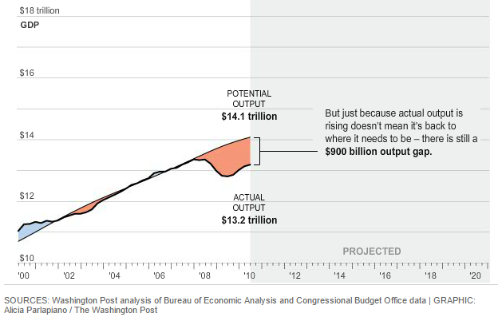
In the above figure, we can see that the reduction in the output gap occurs mainly between the potential GDP and the real GDP of the economy only until the end of the year 2007. However, after 2007, larger output level is being produced showing the situation of the recession around that time. It also resulted into lag in the activities of the production under current conditions of the economy. (Irwin, 2015)

Works Cited
Output Gap and Financial Assumptions from the Board of Governors. (2014, March 14). Retrieved from Philadelphiafred.org: https://www.philadelphiafed.org/research-and-data/real-time-center/greenbook-data/gap-and-financial-data-set
APPELBAUM, B. (2011). Stimulus by Fed Is Disappointing, Economists Say. NewYork Times.
Irwin, N. (2015). Why it doesn't feel like a recovery. Washington Post.
RESERVE, F. (2015). FOMC: Transcripts and Other Historical Materials, 2009. Retrieved from fderalreserve.gov: http://www.federalreserve.gov/monetarypolicy/fomchistorical2009.htm

